SOLAR WI-FI WEATHER STATION
A project work submitted
in partial fulfillment of the requirements
for the award Degree of

BACHELOR OF TECHNOLOGY
IN
ELECTRICAL AND ELECTRONICS ENGINEERING

by

K. MOHITH KUMAR (20L65A0208) S. SURESH KRISHNA (20L65A0212)
CH.V. MANI CHANDAN (20L65A0217) M. HARIKA (20L65A0224)

under the guidance of

Sri. T. JYOYHI, M. Tech.,(Ph.D)
Asst. Professor



DEPARTMENT OF ELECTRICAL & ELECTRONICS ENGINEERING
CHAITANYA ENGINEERING COLLEGE, VISAKHAPATNAM
(NBA and NAAC Accredited, Affiliated to J.N.T. University, Kakinada)
2021

Acknowledgements

We wish to express our sincere gratitude to our guide Sri. T. JYOTHI, Asst. Professor, Department of Electrical and Electronics Engineering for his invaluable guidance and co-operation, of this project. His guidance made the earliest completion of our project work.

We would also like to thank the Head of the department, Dean (R&D) and Principal for being co-operative throughout our project work.

We would also like to thank the teaching and non-teaching staff of the department for being co- operative throughout our project work.

K. MOHITH KUMAR (20L65A0208)
S. SURESH KRISHNA (20L65A0212)
CH.V. MANI CHANDAN (20L65A0217)
M. HARIKA (20L65A0224)
CERTIFICATE

This is to certify that this project work entitled “SOLAR WEATHER STATION” has been successfully carried out by

K. MOHITH KUMAR (20L65A0208)
S. SURESH KRISHNA (20L65A0212)
CH.V. MANI CHANDAN (20L65A0217)
M. HARIKA (20L65A0224)

in partial fulfillment of the requirements for the award of the degree of Bachelor of Technology in Electrical and Electronics Engineering, CHAITANYA ENGINEERING COLLEGE, is a bonafide record of the work done by them under my guidance and supervision.

Sri. Dr. G. SURYA KALYAN, Sri. T. JYOTHI,
Professor, Assistant Professor,
Head of the Department Project Guide

ABSTRACT

Solar weather station is a device that measures various meteorological parameters such as temperature, humidity, wind speed and direction, solar radiation, and atmospheric pressure. These measurements are used to forecast weather conditions, which can be helpful for various purposes such as agriculture, transportation, and aviation.
The solar weather station operates using solar energy, which makes it independent of external power sources. The device consists of several sensors that measure different parameters and a microcontroller that processes the data and sends it to a cloud-based platform for storage and analysis. The collected data can be accessed remotely through a web or mobile application.
In addition to weather forecasting, solar weather stations can also be used for climate monitoring, scientific research, and environmental protection. They can provide valuable information about the impacts of climate change and help in developing strategies to mitigate its effects

As the Wi-Fi hotspots are increasingly becoming common in the recent times, the existing infrastructure can be used to develop a cost-effective solution to enable the existing appliances with IOT. Most of the current solutions for home automation and industry control use GSM/GPRS for connectivity. An overview of IOT, its architecture and protocol suite is presented in this paper. This paper also aims to prototype a solution to enhance the old appliances and make them smart. Such a system can be used in a wide range of applications such as home automation, smart agriculture, smart industry. Cloud based platforms help to connect to the things around us so that we can access anything at any time and any place in a user-friendly manner using customized portals and in-built applications. Hence, cloud acts as a front end to access IOT. Applications that interact with devices like sensors have special requirements of massive storage to store big data, huge computation power to enable the real time processing of the data, information and high-speed network to stream audio or video.

S.NO | CONTENTS | PAGE NO:
 | CHAPTER 1
1.1 | INTRODUCTION | 2
1.2 | ADVANTAGES | 3
1.3 | DISADVANTAGES | 4
1.4 | OBJECTIVE | 5-7
1.5 | LITERATURE SURVEY | 8-9
1.6 | BASIC IDEA OF SOLAR WEATHER STATION | 10-12
 | Chapter 2
2.1 | DESCRIPTION OF THE PROJECT | 14-15
2.2 | ARCHITECTURE HISTORY | 16-17
 | CHAPTER 3
 | WORKING OF THE PROJECT
3.1 | HARDWARE COMPONENTS | 19
3.1.1 | ARDUINO UNO | 19-20
3.1.1.1 | SPECIFICATIONS | 20
3.1.2 | ESP 8266 | 21
3.1.2.1 | SPECIFICATIONS | 22
3.1.3 | RAIN DROP SENSOR | 23
3.1.3.1 | SPECIFICATIONS | 24
3.1.4 | DHT11 | 25
3.1.4.1 | SPECIFICATIONS | 26
3.1.5 | GY1145 UV SENSOR | 27
3.1.5.1 | SPECIFICATIONS | 28
3.1.6 | BATTERY | 29
3.1.6.1 | SPECIFICATIONS | 30
3.1.7 | SOLAR PANEL | 31
3.1.7.1 | SPECIFICATIONS | 32
3.1.8 | LCD DISPLAY | 33
3.1.8.1 | SPECIFICATIONS | 34
3.2 | SOFTWARE | 35
3.2.1 | ARDUINO IDE INSTALLATION | 35-36
3.2.2 | HOW TO SETUP ARDUINO UNO WITH IDE | 36-40
3.3 | CODE | 41-47
3.3.1 | THINGSPEAK | 48-49
3.4 | CONSTRUCTION | 50
3.5 | CIRCUIT DIAGRAM | 51
3.6 | BLOCK DIAGRAM | 52
3.7 | WORKING | 53-54
 | CHAPTER 4
4.1 | RESULT | 56
 | CHAPTER 5
5.1 | CONCLUSION | 58
5.2 | FUTURE SCOPE | 59-60
5.3 | REFERENCES | 61

FIG NO. | LIST OF FIGURES | PG NO.
1.0 | AURDINO UNO | 19
1.1 | ESP 8266 | 21
1.2 | RAIN DROP SENSOR | 23
1.3 | DHT11 | 25
1.4 | GY1145 UV SENSOR | 27
1.5 | GY1145 UV SENSOR | 29
1.6 | SOLAR PANEL | 31
1.7 | LCD DISPLAY | 33
1.8 | ARDUINO IDE WEBSITE | 35
1.9 | ARDUINO IDE DOWNLOADED | 35
2.0 | ARDUINO IDE DEFAULT PROGRM | 36
2.1 | CONFIGURE ARDUINO UNO WITH PC | 36
2.2 | ARDUINO UNO PORT | 37
2.3 | TOOLS SELECTION | 37
2.4 | PORT SELECTION | 38
2.5 | SAVED CODE INTERFACE | 38
2.6 | COMPILATION BUTTON | 39
2.7 | CODE UPLOADING | 40
2.8 | THINGSPEAK WEBSITE | 48
2.9 | HUMIDITY AND RAIN GRAPH | 48
3.0 | TEMPERATURE AND UV GRAPH | 49
3.1 | CIRCUIT DIAGRAM | 51
3.2 | BLOCK DIAGRAM | 52
3.3 | COMPLETE DEVICE INTERFACE | 54

CHAPTER 1

1.1 Introduction:
Why a Weather Station?
Imagine you are residing at a place that is far away from the meteorological department. In such a case, the weather predictions you get may not be the most precise. This is where home weather stations become more advantageous. This small weather station can provide accurate data regarding the weather parameters of where you live.
Today, data on localized weather, known as microclimates, is the new frontier for more precise and accurate weather forecasting. As a result, the collection of weather data is becoming increasingly smaller and gridded.
PURPOSE OF USING
- Weather is a one of the kind thing which cannot be predicted …
- Human cannot change the weather but can forecast it…
- By forecasting a weather we may plan our work according to it..
- And because of this we may protect ourselves from natural disasters like Tsunamis, Cyclones, Hurricanes e.t.c
- In order to predict all these we need a weather station that is what you are going to see.

1.2 ADVANTAGES:
The advantages of a solar weather station include:

Eco-friendly: The solar weather station is powered by solar panels, which makes it eco-friendly as it reduces the use of non-renewable resources.

Cost-effective: The solar weather station requires low maintenance and has low operating costs as it runs on solar power.

Efficient: The solar weather station is highly efficient as it uses solar panels to generate energy and can function even in remote areas where grid power is not available.

Reliable: The solar weather station can provide reliable weather data as it is not affected by power outages or interruptions.

Versatile: The solar weather station can be easily installed in various locations such as farms, airports, or research centers.

Scalable: The solar weather station can be scaled up or down depending on the requirements and can be easily integrated with other systems.

Real-time data: The solar weather station can provide real-time weather data, which is important for weather forecasting, agriculture, aviation, and other applications.

1.3 DISADVANTAGES
The disadvantages of solar weather stations include:

Dependence on sunlight: Since solar weather stations rely on solar panels to generate power, they may not function effectively in areas with limited sunlight or in overcast weather conditions.

High initial cost: The cost of setting up a solar weather station can be relatively high due to the expense of the solar panels and associated equipment.

Limited battery life: Although solar panels can generate electricity during the day, they cannot do so at night. This means that solar weather stations may need to rely on battery power during periods of low sunlight, which can limit their operational time.

Maintenance requirements: Solar panels require regular maintenance to ensure they continue to function effectively. This can involve cleaning and monitoring for damage or wear.

Environmental impact: While solar weather stations are considered to be more environmentally friendly than traditional weather stations, the production and disposal of solar panels can still have an impact on the environment

1.4 objective:
"Weather" is short for meteorology, which means the measurement of the state of the atmosphere. And it's pretty broad: indoor air quality, outdoor atmosphere, outdoor pollution weather forecasting, pollution… all these variables fall within the scope of meteorology. The weather station is a device that can measure these elements with sensors and provide you with all the data on a screen. A weather station is also called a weather station, weather park, or weather shelter. It is a measuring device, consisting of different sensors and fulfilling different functions.
While there are massive, highly sophisticated ones used by national meteorological services, some are dedicated to the general public. A weather station can act as a thermometer, clock, sound level meter, hygrometer, anemometer, barometer, etc. in the home barometer, it can also provide information on air quality, moon phase, or indoor pollution levels. Everything you need to get your own weather forecast!
The use of weather stations in private homes has become more widespread in recent years. It has become a fashionable object (especially the connected weather station, the flagship of IoT, and connected objects). Gardeners, farmers, sailors, navigators, hikers, mountain bikers, carpenters, labourers… anyone who needs accurate weather information can benefit greatly from a weather station. Or even for a person who just wants to know if the weather will be bad or if they do not want o miss out on the sunshine.
But that's not all: many weather stations also provide data related to the atmosphere inside the house, such as air quality, indoor air pollution humidity, and temperature.
So, why use a weather station at home? It's simple, to better predict the weather and to analyse the quality of the atmosphere at home. This makes it possible to control the interior environment of the house, but also to better.
Now let's get into the details of the functions of a weather station. Wind, pressure, temperature, humidity levels, weather forecasts, atmospheric quality. what does a weather station measure?
The variables that a weather station measures depend on the individual station. More importantly, they can be divided into two broad categories: variables in the external environment (such as weather) and those in the internal environment (such as air quality).
Let's start with the external variables:
- The outside temperature
- Atmospheric pressure
- Wind speed and direction
- Rain gauge
- Hygrometer (humidity level)
- Precipitation forecasts
- The height and type of clouds
- The dew point
- Visibility
Now let's move on to the variables inside the house:
- Time
- Indoor temperature
- The indoor humidity level
- Air quality
- The level of pollution (especially NO2, CO2, fine particles)
- The noise level

Combining these data gives you the power to act on them by regulating them. Using a weather station to make these measurements is the first step, but the real question.
As mentioned, there is not just one type of weather station. There are many of them!

What are the different types of weather stations and how do I choose?
Wired or wireless, connected or not, with or without a display, with one function or another. there is no single model of weather station.
Note that we are talking about home (or business but commercially available) weather stations here and not professional models.
So first of all, to choose your ideal weather station, you need to define the use you will have of it. Why do you need a weather station? To improve your air quality at home? For sailing? For gardeners? To farm? For reliable weather information? All of the above?
The more you depend on the weather, the more important it is that you can predict it accurately. The more sensitive the people in your home are to air pollution, the more important it is to maintain good indoor air quality. So which weather station There are 2 main types of weather stations: the classic weather station with sensors and the connected weather station or smart weather station. The classic weather station (with sensors)
This is the entry-level weather station model. Efficient but limited, it uses sensors to provide the collected data on a screen. The display remains in real-time despite a very affordable price.
The connected weather station is the most advanced and is a truly connected object. It also uses sensors to collect real-time data from the screen, but in addition, it transmits this information to your smartphone or tablet. Using WIFI,connected It is a more complete, more precise, and more practical device. but more expensive. However, for effective data measurement both inside and outside the You now know everything about the weather station: what it is, its functions and its different variations. All you have to do is assess your needs, compare the offers and choose the product that meets all your requirements.
1.5 Literature Survey
The key gathering of the information is done through the internet from the different websites like Wikipedia, Quora, The instructables e.t.c gained knowledge on the equipment used in the weather station prepared the notes on the different parameters of the devices used like input and output voltages, operating current, power rating e.t.c
Weather Monitoring Station (WMS) is one of the most crucial instruments installed in Solar PV Power plants. A weather monitoring station can be immensely helpful in monitoring the efficiency and performance of any solar power plant. The data from the WMS can be used to get many insights about the plant operation and possible avenues to increase the plant output. As we are aware, even a small decline in the plant efficiency can significantly affect the energy output and hence the ROI. This article tries to enlist all the possible benefits from a WMS to the plant owners. t is very important to understand that a WMS cannot help you change the weather parameters, but it helps you to analyze and predict them so as to get maximum output from your solar plant. Photovoltaic (PV) system performance depends on both the quality of the system and the weather. As the weather varies, the output of the PV system changes. The key factor affecting the PV system performance is the solar radiation data. But along with solar radiation data, the weather parameters like ambient temperature, relative humidity, wind speed, wind direction, atmospheric pressure, and rain are the other important factors affecting the performance. The air temperature, relative humidity, and module temperature have a significant influence on the efficiency of solar modules. The performance of solar modules is temperature-dependent. Module temperature gives an indication of a change in the efficiency of the modules. If the module surface temperature rises beyond the specified limit of the manufacturer, the efficiency of the panels will be reduced. This will give the poor generation and will affect the plant performance. Data about amount and frequency of precipitation (rainfall) can help to explain low energy yields at high solar radiation. If we can accurately measure the total useable incident radiation under any environmental conditions then, we will be able to calculate if the PV system is generating electricity as per the expectations. The data of all these sensors can be used to schedule the maintenance of the plant. Typically, a weather monitoring station monitors parameters such as solar radiation, other weather conditions such as wind velocity, wind direction, humidity, module temperature etc. Weather stations also calculate performance ratio (PR) of the solar power plant using all the captured data. The performance ratio (PR) for a solar power plant is defined in IEC 61724 [1] and is a metric commonly used to measure solar photovoltaic (PV) plant performance for acceptance and operations testing. The PR measures how effectively the plant converts sunlight collected by the PV panels into AC energy delivered to the load to what would be expected from the panel rating. This data can be accessed over the cloud as well.

How Does A WMS Help Improve The Plant Performance?
Data from the WMS helps in planning out the maintenance activities. For optimum operations, it is necessary that the solar panels are cleaned periodically. The decline in efficiency, observed in the WMS data can prompt the user to carry out these maintenance activities. Weather data and weather prediction can help in scheduling the maintenance and repairs. Doing maintenance and repairs at the wrong time could prove to be a costly affair.
Wind velocity is important from the plant safety perspective. The heavy wind loads at a site may cause damage to the PV modules. With accurate wind speed and direction data, a user can take the necessary steps to prevent damages and loss. Various types of sensors, like cup type mechanical sensors and ultrasonic type sensors, are available and depending upon the requirements, one can choose the correct sensor.

1.6 Basic Idea of solar Weather station:
Remote sensors used in wireless weather stations are powered by one of two sources of energy; batteries or solar power systems. Remote sensor and batteries will eventually be depleted and must be replaced on a regular basis. Unfortunately data can be lost during those times. Many wireless weather stations have to be completely reset when replacing sensor batteries, which typically means you will have to remove the batteries from the indoor console as well (always power up the weather sensors first before turning on the indoor console). A solar powered weather station has the advantage of being able to provide energy for long periods of time. The downside is that over time, solar power systems collector panels degrade and will eventually have to be replaced. Overall, solar power systems are the most dependable source of power for remote sensors.
Typically, solar powered weather stations are made up of several components. The solar panels power the sensors during the hours of daylight and at the same time recharge an attached battery pack, which is then used for sensor power after the sun goes down. In some professional weather stations, such as the Davis Vantage Pro2, the solar panels charge up a capacitor that then discharges during night time providing power to the sensors. This system also relies on a lithium battery pack for backup power should the capacitive discharge component be depleted. Rechargeable lithium batteries are also highly recommended for use as as opposed to rechargeable alkaline batteries. Lithium batteries last longer and are much less susceptible to failure in cold temperatures. After following the weather station set up guidelines elsewhere on this site, there may be times during the day (early in the morning and late in the afternoon) when nearby buildings and landscaping throw the area your solar powered weather station sensors are placed into shadow. You may also live in a location that is prone to a significant number of cloudy days or long periods of darkness such as Alaska. Should any of these scenarios be the case, before you purchase your solar powered weather station it would be prudent to investigate the effectiveness of the solar energy system in being able to power the sensors during those conditions. This would definitely be an issue to discuss with a technical support representative.
Flexibility, Automation, Integration for the Solar Industry
Three turnkey meteorological (met) monitoring systems provide options suitable for solar energy projects of any scale. Our standard systems can be customized to suit most requirements.
- – Professional-grade sensors
- – Various solar radiation sensor classes
- – Multiple panel temps option
Multiple interfaces and monitoring options (Modbus RTU, Modbus TCP, BacNet, Browser Interface and more) automate data collection and integrate with SCADA or other plant monitoring systems.
Easy Installation and Operation Saves Money for PV Plants
CWS weather stations are preferred for ease of installation. The systems come complete, tested and pre-configured to facilitate easy installation by your local site electrician or electrical contractor. They do not require programming or special training to install, operate and maintain.
No long-term contract required. You own the equipment and the data. We are readily available for free technical assistance in the unlikely event it is required.
Parameters for Weather Monitoring at Solar Farms
Environmental monitoring is critical to optimizing the efficiency of solar power generation.
- Solar radiation (irradiance): The most important measurement, key to monitoring availability of sunlight.
- – Temperature (ambient/panel): Critical relative to performance as increasing temperatures correlate to decreased efficiency.
- – Wind speed/direction: Less critical, however, wind is a cooling factor which affects efficiency.
- – Precipitation: May interfere, especially in solid form.
Experienced in Weather Monitoring
We’ve been in the weather monitoring business for 40 years and working specifically with the solar energy industry since 2009. We’ve provided weather stations to hundreds of solar energy projects from small to utility-scale.

Chapter 2

2.1 DESCRIPTION OF THE PROJECT:
A solar weather station is a type of weather monitoring system that uses solar power as its main source of energy. These weather stations typically consist of sensors and instruments that collect data about various weather parameters such as temperature, humidity, rainfall, wind speed and direction, and solar radiation.
The solar panels in a solar weather station convert sunlight into electrical energy, which is used to power the various sensors and instruments. This makes solar weather stations an ideal solution for remote areas where access to electricity is limited, as they can operate completely off-grid.
In addition to being energy-efficient and environmentally friendly, solar weather stations are also highly accurate and reliable. The data collected from these stations is often used by meteorologists, researchers, and other professionals to study weather patterns and make important decisions based on that information.
Solar weather stations can be configured in a variety of ways depending on the specific needs of the user. Some stations are designed to be mobile and can be easily transported to different locations, while others are built to withstand harsh environmental conditions and can be left in place for long periods of time.
Overall, solar weather stations provide a reliable and cost-effective way to monitor weather conditions, and are an important tool for understanding and predicting changes in the environment.
A solar weather station is a type of weather monitoring system that uses solar power as its main source of energy. These weather stations typically consist of sensors and instruments that collect data about various weather parameters such as temperature, humidity, rainfall, wind speed and direction, and solar radiation.
The solar panels in a solar weather station convert sunlight into electrical energy, which is used to power the various sensors and instruments. This makes solar weather stations an ideal solution for remote areas where access to electricity is limited, as they can operate completely off-grid.
In addition to being energy-efficient and environmentally friendly, solar weather stations are also highly accurate and reliable. The data collected from these +stations is often used by meteorologists, researchers, and other professionals to study weather patterns and make important decisions based on that information.
Solar weather stations can be configured in a variety of ways depending on the specific needs of the user. Some stations are designed to be mobile and can be easily transported to different locations, while others are built to withstand harsh environmental conditions and can be left in place for long periods of time.
Overall, solar weather stations provide a reliable and cost-effective way to monitor weather conditions, and are an important tool for understanding and predicting changes in the environment.
weather station is a facility with instruments and equipment to make observations of atmospheric conditions in order to provide information to make weather forecasts and to study the weather and climate.
Weather Stations feature an Orion all-in-one sensor unit with ultrasonic wind direction and speed measurements, a highly-accurate impact rain sensor, capacitive relative humidity, temperature and barometric pressure readings.

2.2 ARCHITECTURE HISTORY:
A solar weather station is a type of weather monitoring system that uses solar power as its main source of energy. These weather stations typically consist of sensors and instruments that collect data about various weather parameters such as temperature, humidity, rainfall, wind speed and direction, and solar radiation.
The solar panels in a solar weather station convert sunlight into electrical energy, which is used to power the various sensors and instruments. This makes solar weather stations an ideal solution for remote areas where access to electricity is limited, as they can operate completely off-grid.
In addition to being energy-efficient and environmentally friendly, solar weather stations are also highly accurate and reliable. The data collected from these stations is often used by meteorologists, researchers, and other professionals to study weather patterns and make important decisions based on that information.
Solar weather stations can be configured in a variety of ways depending on the specific needs of the user. Some stations are designed to be mobile and can be easily transported to different locations, while others are built to withstand harsh environmental conditions and can be left in place for long periods of time.
Overall, solar weather stations provide a reliable and cost-effective way to monitor weather conditions, and are an important tool for understanding and predicting changes in the environment. In the early 1800's and 1900's, home weather stations typically consisted of a few specialized analog tools. Humidity gauges measure the moisture content in the air, while rain gauges and barometers help determine previous and future rainfall. This information could then be tracked in order to identify trends.
out say that Mount Washington has since 1870 hosted “the world's first mountaintop weather station” (11 April, p 22). But the Meteorologists Observatorium Hohenpeißenberg was opened on 1 January 1781 and thus predates the US example by 89 years. A weather station is a device that collects data related to the weather and environment using many different sensors. Weather stations are also called weather center, personal weather stations, professional weather stations, home weather stations, weather forecaster and forecasters.

CHAPTER 3

WORKING OF THE PROJECT
3.1 HARDWARE COMPONENTS:
3.1.1 ARDUINO UNO:
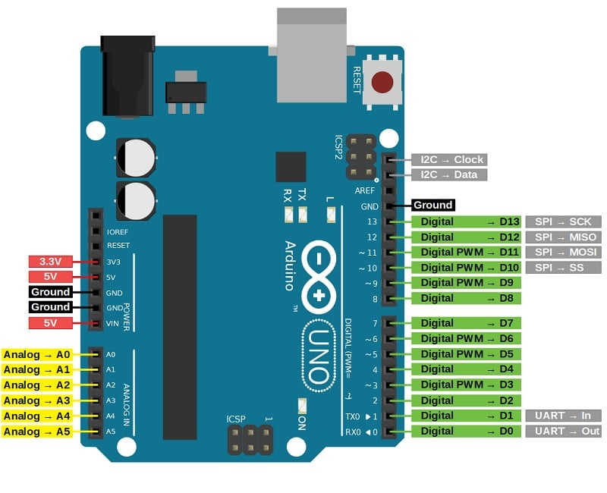
FIG. 1.0 ARDUINO UNO
Arduino Uno is a microcontroller board based on the ATmega328P microcontroller. It is one of the most popular and widely used development boards in the world of electronics and microcontroller programming.
The board has 14 digital input/output pins, 6 analog inputs, a 16 MHz quartz crystal, a USB connection, a power jack, an ICSP header, and a reset button. It can be powered by either a USB cable or an external power supply.
The digital input/output pins can be used for a variety of purposes, such as controlling LEDs, motors, and other electronic components. The analog inputs allow you to measure voltage levels from sensors or other analog devices.
The board is programmable using the Arduino Integrated Development Environment (IDE), which is based on the C++ programming language. The IDE provides a simple and intuitive interface for writing and uploading code to the board.
The Arduino Uno is widely used in a variety of applications, from robotics and automation to home automation and Internet of Things (IoT) projects. Its ease of use, flexibility, and low cost make it an ideal choice for both beginners and advanced users alike.

3.1.1.1 SPECIFICATIONS:
The specifications of the Arduino Uno board:
Microcontroller: ATmega328P
Operating Voltage: 5V
Input Voltage (recommended): 7-12V
Input Voltage (limit): 6-20V
Digital I/O Pins: 14 (of which 6 provide PWM output)
Analog Input Pins: 6
DC Current per I/O Pin: 20 mA
DC Current for 3.3V Pin: 50 mA
Flash Memory: 32 KB (ATmega328P) of which 0.5 KB used by bootloader
SRAM: 2 KB (ATmega328P)
EEPROM: 1 KB (ATmega328P)
Clock Speed: 16 MHz
The board also has a USB interface for programming and serial communication, and it is compatible with various shields and modules, making it easy to expand its functionality for a wide range of applications.

3.1.2 ESP 8266:
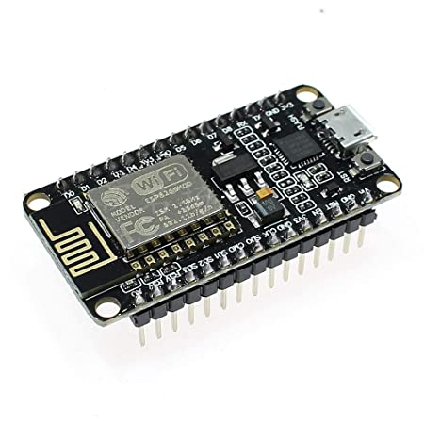
FIG 1.1 ESP 8266
The ESP8266 is a low-cost, low-power Wi-Fi SoC (System-on-a-Chip) designed by the Chinese company Espress if Systems. It was first introduced in 2014 and quickly became popular among makers, hobbyists, and IoT enthusiasts due to its low cost, ease of use, and built-in Wi-Fi connectivity.
The ESP8266 module features a powerful 32-bit Tensilica L106 microcontroller running at 80 MHz, 64 KB of instruction RAM, and 96 KB of data RAM. It also has 4 MB of flash memory for storing firmware and data. The module has 17 GPIO pins that can be used for input and output, as well as for communication with other devices.
One of the most attractive features of the ESP8266 module is its built-in Wi-Fi connectivity. It supports 802.11 b/g/n Wi-Fi standards and can connect to any Wi-Fi network. This makes it easy to integrate the module into IoT projects that require wireless connectivity, such as home automation, smart lighting, and remote monitoring.
The ESP8266 can be programmed using a variety of programming languages, including C, C++, and MicroPython. It can also be programmed using the Arduino IDE, which makes it easy
Overall, the ESP8266 module is a versatile and powerful platform for building IoT applications. Its low cost, ease of use, and built-in Wi-Fi connectivity make it a popular choice a makers, hobbyists, and IoT enthusiasts.
3.1.2.1 SPECIFICATIONS:
The ESP8266 Wi-Fi module is a low-cost, low-power wireless system-on-a-chip (SoC) that is widely used in IoT applications. Here are some of its features and specifications:
Wi-Fi connectivity: The ESP8266 module supports 802.11 b/g/n Wi-Fi connectivity, allowing it to connect to any Wi-Fi network.
Microcontroller: The ESP8266 module contains a powerful 32-bit Tensilica L106 microcontroller running at 80 MHz
Memory: The ESP8266 module comes with 64 KB of instruction RAM and 96 KB of data RAM. It also has 4 MB of flash memory for storing firmware and data.
GPIO: The ESP8266 module has 17 GPIO pins that can be used for input and output, as well as for communication with other devices.
Analog input: The ESP8266 module has one analog input pin that can be used to read analog values.
Communication interfaces: The ESP8266 module supports SPI, I2C, and UART communication interfaces, making it easy to communicate with other devices.
Power consumption: The ESP8266 module is designed to be very low power, consuming only 10 µA in sleep mode.
Operating voltage: The ESP8266 module operates at 3.3V DC.
Programming: The ESP8266 module can be programmed using a variety of programming languages, including C, C++, and MicroPython.
Support for AT commands: The ESP8266 module supports AT commands, making it easy to integrate with existing systems.
Overall, the ESP8266 Wi-Fi module is a versatile and powerful wireless SoC that can be used in a wide range of applications, from home automation to industrial control systems.

3.1.3 RAIN DROP SENSOR:
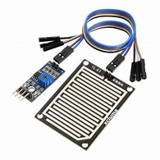
FIG 1.2 RAIN DROP SENSOR
Raindrop sensors are electronic devices that are used to detect the presence of water or rain. They typically consist of two components: a sensor board and a control board.
The sensor board of a raindrop sensor typically contains a series of conductive plates or wires that are separated by a small distance. When a water droplet falls onto the plates or wires, it creates a connection between them, allowing an electrical current to flow. This change in electrical conductivity is detected by the control board, which processes the data and sends it to a microcontroller or computer for further analysis.
Most raindrop sensors also include a potentiometer or adjustable resistor that can be used to set the sensitivity of the sensor. This allows the sensor to detect different levels of rainfall, from light drizzle to heavy rain.
Raindrop sensors can be used in a wide range of applications, including weather monitoring systems, irrigation systems, and flood detection systems. They can be connected to microcontrollers, computers, or other devices to provide real-time data on rainfall levels, which can be used for a variety of purposes, such as watering plants or predicting weather patterns.
Overall, the working principle of a raindrop sensor is based on the electrical conductivity of water and the creation of a connection between conductive plates or wires when water droplets fall onto them. This makes raindrop sensors a simple and effective way to detect the presence of rain or water in various applications.

3.1.3.1 SPECIFICATIONS:
The specifications of a raindrop sensor can vary depending on the specific model or manufacturer, but some common specifications include:
Input voltage: Raindrop sensors typically operate at a voltage of 3.3V or 5V DC.
Output signal: Raindrop sensors can produce analog or digital output signals. Analog output signals provide a voltage proportional to the amount of rainfall, while digital output signals indicate the presence or absence of rainfall.
Sensitivity: Raindrop sensors have adjustable sensitivity, which can be set using a potentiometer or adjustable resistor. This allows the sensor to detect different levels of rainfall, from light drizzle to heavy rain.
Detection area: Raindrop sensors have a detection area that can range from a few square millimeters to several square centimeters.
Response time: The response time of a raindrop sensor refers to how quickly it can detect the presence of water or rain. This can vary depending on the specific model, but typical response times range from a few milliseconds to a few seconds.
Operating temperature: Raindrop sensors can operate at temperatures ranging from -40°C to 85°C.
Dimensions: Raindrop sensors come in a variety of sizes and shapes, with typical dimensions ranging from a few millimeters to several centimeters.
Material: The conductive plates or wires on a raindrop sensor are typically made of materials such as copper or silver.
Overall, the specifications of a raindrop sensor will depend on the specific model and manufacturer, but these common specifications can give you an idea of what to look for when choosing a raindrop sensor for your project.

3.1.4 DHT11:
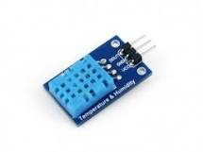
FIG 1.3 DHT11
The DHT11 is a low-cost temperature and humidity sensor that is commonly used in electronics projects. It consists of a thermistor for measuring temperature and a capacitive humidity sensor for measuring relative humidity. The DHT11 sensor is housed in a compact package and can be easily integrated into various applications.
The DHT11 sensor communicates using a single-wire digital interface, which makes it easy to interface with microcontrollers and other devices. The sensor is designed to provide accurate temperature and humidity measurements with a resolution of 1°C and 1% RH, respectively.
The operating range of the DHT11 sensor is from 0°C to 50°C for temperature and from 20% to 90% for relative humidity. The accuracy of the temperature measurement is ±2°C, while the accuracy of the relative humidity measurement is ±5%.
To use the DHT11 sensor, it is typically connected to a microcontroller or other device using a 3-pin interface. The sensor requires a supply voltage of 3 to 5V DC and consumes very little power, making it ideal for battery-powered applications.
Overall, the DHT11 temperature and humidity sensor is a simple and cost-effective solution for measuring environmental conditions in a wide range of applications, including home automation, weather monitoring, and industrial control systems.

3.1.4.1SPECIFICATIONS:
specifications of the DHT11 temperature and humidity sensor:
Operating Voltage: The DHT11 operates at a voltage of 3 to 5 volts DC.
Temperature Measurement Range: The temperature measurement range of the DHT11 is from 0°C to 50°C (32°F to 122°F).
Temperature Measurement Accuracy: The accuracy of the temperature measurement is ±2°C (±3.6°F).
Humidity Measurement Range: The humidity measurement range of the DHT11 is from 20% to 90% RH (Relative Humidity).
Humidity Measurement Accuracy: The accuracy of the humidity measurement is ±5% RH.
Resolution: The DHT11 provides a resolution of 1°C for temperature and 1% RH for humidity.
Response Time: The response time of the DHT11 sensor is less than 5 seconds.
Dimensions: The dimensions of the DHT11 sensor are 12mm x 15.5mm x 5.5mm.
Communication: The DHT11 sensor communicates with the microcontroller or other device using a single-wire digital interface.
Power Consumption: The DHT11 consumes very little power, typically less than 1mA during active sensing.

3.1.5 GY1145 UV SENSOR:
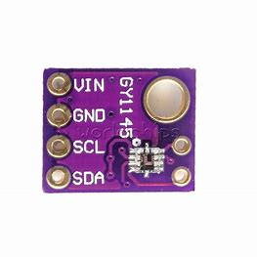
FIG 1.4 GY1145 UV SENSOR
The GY1145 UV sensor is a compact and low-cost ultraviolet light sensor that is commonly used in electronics projects. It is capable of detecting both UVA and UVB radiation and can be used to measure the UV index, a measure of the strength of ultraviolet radiation from the sun.
The GY1145 UV sensor uses a photodiode to detect ultraviolet radiation and converts it into a voltage signal. The sensor has a spectral range of 200-400nm and is capable of measuring UV radiation in the range of 0-15 Mw/cm².
The GY1145 UV sensor communicates with a microcontroller or other device using the I2C communication protocol. It requires a supply voltage of 3.3 to 5 volts DC and consumes very little power, making it ideal for battery-powered applications.
One of the key features of the GY1145 UV sensor is its ability to measure the UV index. The UV index is a measure of the strength of ultraviolet radiation from the sun and is used to inform people about the risk of sunburn and skin damage. The GY1145 UV sensor provides a simple way to measure the UV index and can be integrated into various applications, including wearable devices and weather stations.
Overall, the GY1145 UV sensor is a versatile and affordable solution for measuring ultraviolet radiation in a wide range of applications, including outdoor recreation, agriculture, and industrial monitoring. Its small size, low power consumption, and I2C interface make it easy to integrate into various projects.

3.1.5.1 SPECIFICATIONS:
specifications of the GY1145 UV sensor:
Spectral Range: 200-400nm
Range of UV radiation measured: 0-15 Mw/cm²
Communication Protocol: I2C
Supply Voltage: 3.3 to 5V DC
Power Consumption: less than 0.5Ma
Dimensions: 12mm x 18mm x 2.1mm
UV Index measurement range: 0-15
Resolution: 0.01
Sensitivity: 0.22V/(Mw/cm²)
Accuracy: ±1 UV index
The GY1145 UV sensor is a low-cost and reliable solution for measuring UV radiation in a variety of applications. Its small size, low power consumption, and I2C interface make it easy to integrate into various projects, including wearable devices, weather stations, and industrial monitoring systems. The sensor is capable of measuring both UVA and UVB radiation, making it useful for a range of applications where monitoring UV exposure is important.

3.1.6 BATTERY:
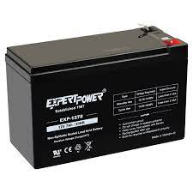
FIG1.5 BATTERY
A 12-volt battery is a type of rechargeable battery that is commonly used to power small to medium-sized electrical devices, such as vehicles, boats, motorcycles, and home appliances. It is designed to provide 12 volts of direct current (DC) power and is typically made up of six cells, each with a voltage of 2 volts.
The cells are connected in series, which means that the positive terminal of one cell is connected to the negative terminal of the next cell. This arrangement produces a total voltage of 12 volts across the battery.
12-volt batteries can be made from various materials, including lead-acid, lithium-ion, and nickel-cadmium. Lead-acid batteries are the most common type and are often used in cars and other vehicles. Lithium-ion batteries are becoming more popular due to their higher energy density and longer lifespan.
The capacity of a 12-volt battery is measured in ampere-hours (Ah), which is a measure of the amount of current the battery can supply over a certain period of time. The higher the Ah rating, the longer the battery can power a device before needing to be recharged.
Overall, 12-volt batteries are a convenient and versatile power source for a wide range of applications, and they are widely available and relatively affordable.
3.1.6.1 SPECIFICATIONS:
Voltage: 12 volts (DC)
Capacity: Typically measured in ampere-hours (Ah), which is a measure of the amount of charge the battery can deliver over a certain period of time. Common capacities for 12V batteries range from 20Ah to 100Ah or more, depending on the application.
Chemistry: The type of chemistry used in the battery can affect its performance, lifespan, and cost. Common chemistries for 12V batteries include lead-acid, lithium-ion, and nickel-cadmium.
CCA: Cold Cranking Amps (CCA) is a measure of the battery's ability to deliver high currents in cold temperatures, typically measured at -18°C. This specification is especially important for automotive applications.
Reserve Capacity: Reserve Capacity (RC) is the amount of time a fully charged battery can sustain a minimum voltage under a constant load, typically measured in minutes. It is an indicator of the battery's ability to provide backup power.
Dimensions: 12V batteries come in various sizes and shapes, depending on the application. Common form factors include group sizes, which are standardized dimensions used for automotive batteries, and rectangular or cylindrical shapes used for other applications.
Weight: The weight of a 12V battery can vary widely depending on its chemistry, capacity, and construction. Lead-acid batteries are typically heavier than lithium-ion or nickel-cadmium batteries.
Cycle Life: The number of charge and discharge cycles a battery can withstand before its performance begins to degrade. This specification is especially important for rechargeable batteries like lithium-ion.
Self-discharge rate: The rate at which the battery loses charge when not in use. This specification is important for batteries that are stored for long periods without use, such as backup power supplies or seasonal equipment.

3.1.7 SOLAR PANEL:
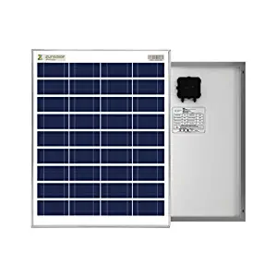
FIG 1.6 SOLAR PANEL
A 9W solar panel is a type of photovoltaic panel that converts sunlight into electrical energy. It typically has a power output of 9 watts, which is determined by the size and efficiency of the solar cells used in the panel.
9W solar panels are relatively small and compact, making them ideal for portable or low-power applications such as charging small electronic devices or powering outdoor lighting systems. They can be used as standalone units or as part of a larger solar power system.
The efficiency of a 9W solar panel can vary depending on the quality and type of solar cells used, as well as environmental factors such as the amount of sunlight available and the temperature. High-efficiency solar cells can produce more power per unit area and are typically more expensive than lower-efficiency cells.
Overall, a 9W solar panel can be a convenient and eco-friendly way to generate electricity for a range of small-scale applications.

3.1.7.1 SPECIFICATIONS:
specifications for a 9W solar panel:
Power Output: 9 watts
Voltage: Generally around 18 volts, but can vary depending on the specific panel and conditions
Current: Typically around 0.5 amps, but can vary depending on the specific panel and conditions
Efficiency: The efficiency of a 9W solar panel can vary depending on the quality and type of solar cells used. High-efficiency panels can have efficiencies of over 20%, while lower-efficiency panels may have efficiencies around 15% or less.
Size: A 9W solar panel can vary in size depending on the specific model, but typically measures around 18 inches by 12 inches or less.
Weight: Typically less than 2 pounds.
Durability: Solar panels are designed to withstand outdoor conditions, but the specific durability and ruggedness of a 9W solar panel can vary depending on the manufacturer and model.
Material: The materials used in a 9W solar panel can vary, but typically include a layer of tempered glass to protect the solar cells and a frame made of aluminum or another lightweight metal.
Warranty: The warranty for a 9W solar panel can vary depending on the manufacturer, but is typically around 10 years for defects in materials and workmanship, and around 25 years for performance guarantees.

3.1.8 LCD DISPLAY:
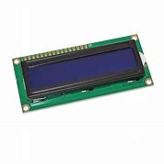
FIG 1.7 LCD DISPLAY
A 16x2 display is a type of alphanumeric liquid crystal display (LCD) that can display 16 characters in each of its two rows, for a total of 32 characters. It is a popular choice for displaying text in a variety of applications, such as in calculators, clocks, and small electronic devices. The display is typically controlled using a microcontroller or similar device, which sends commands to the display to write or clear characters at specific positions. The display can also be backlit to improve visibility in low light conditions.

The term LCD stands for liquid crystal display. It is one kind of electronic display module used in an extensive range of applications like various circuits & devices like mobile phones, calculators, computers, TV sets, etc. These displays are mainly preferred for multi-segment light-emitting diodes and seven segments. The main benefits of using this module are inexpensive; simply programmable, animations, and there are no limitations for displaying custom characters, special and even animations, etc.

3.1.8.1 SPECIFICATIONS:
Character Size: The display consists of 2 rows and 16 columns, with each character taking up 5x8 pixels.
Operating Voltage: The recommended operating voltage is usually between 4.5V to 5.5V.
Power Consumption: The display typically consumes around 1mA to 2mA of current.
Backlight: The display may come with a built-in LED backlight for improved visibility in low light conditions.
Contrast Control: The display may also include a potentiometer for adjusting the contrast of the characters.
Interface: The display is usually interfaced with a microcontroller using a 16-pin interface that includes pins for power, ground, data, and control signals.
Display Driver: The display is typically driven by a driver chip, such as the Hitachi HD44780, which is compatible with a wide range of microcontrollers.
Operating Temperature: The display can typically operate in a temperature range of -20°C to 70°C.
Dimensions: The display typically measures around 80mm x 36mm x 12mm (L x W x H).
Overall, a 16x2 LCD display is a versatile and widely used display that is suitable for a range of applications, including industrial control systems, instrumentation, consumer electronics, and hobbyist projects

3.2 SOFTWARE
3.2.1 Arduino IDE Installation
For uploading our first program into Arduino Nano first set up the IDE first. Follow these steps to complete installation of IDE.
Step 1: Download Arduino IDE from Arduino official site by clicking

INCLUDEPICTURE "https://linuxhint.com/wp-content/uploads/2022/08/How-to-Program-Arduino-Nano-2.png" \* MERGEFORMATINET INCLUDEPICTURE "https://linuxhint.com/wp-content/uploads/2022/08/How-to-Program-Arduino-Nano-2.png" \* MERGEFORMATINET 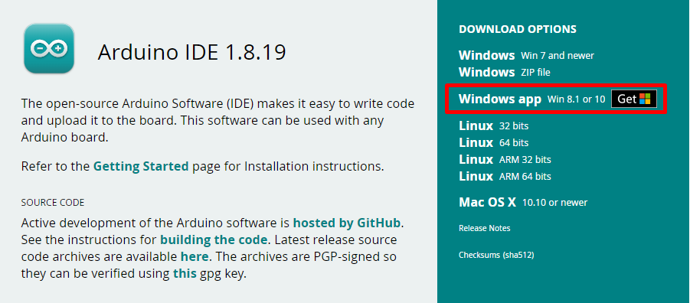 FIG1.8 ARDUINO IDE WEBSITE
Step 2: Once the Arduino IDE is downloaded. After installing IDE press the Windows key and type IDE in the search bar then click Open as shown below:

INCLUDEPICTURE "https://linuxhint.com/wp-content/uploads/2022/08/How-to-Program-Arduino-Nano-3.png" \* MERGEFORMATINET INCLUDEPICTURE "https://linuxhint.com/wp-content/uploads/2022/08/How-to-Program-Arduino-Nano-3.png" \* MERGEFORMATINET 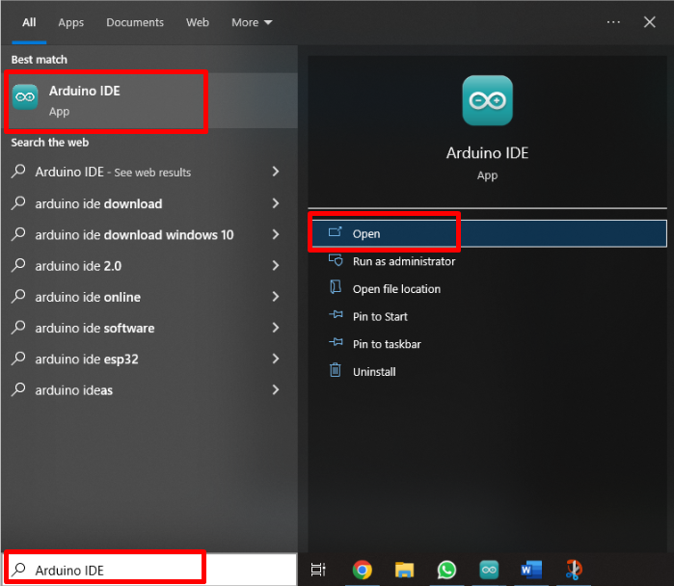
Fig 1.9 ARDUINO IDE DOWNLOADED

Step 3: New window will open showing the Arduino IDE default program.

INCLUDEPICTURE "https://linuxhint.com/wp-content/uploads/2022/08/How-to-Program-Arduino-Nano-4.png" \* MERGEFORMATINET INCLUDEPICTURE "https://linuxhint.com/wp-content/uploads/2022/08/How-to-Program-Arduino-Nano-4.png" \* MERGEFORMATINET 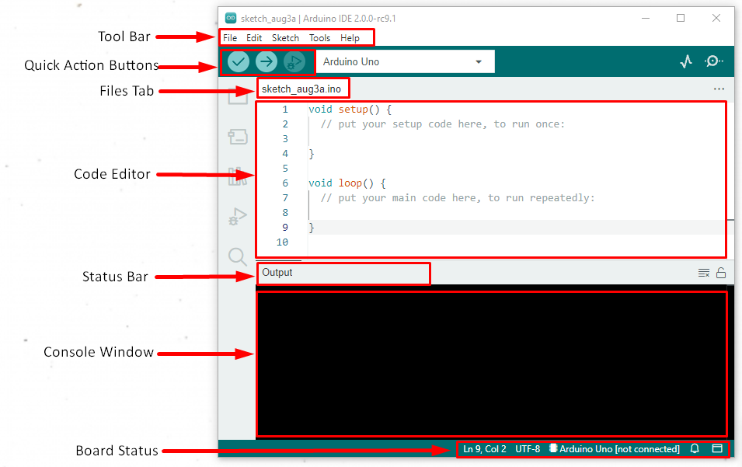Fig 2.0 ARDUINO IDE DEFAULT PROGRM
3.2.2 How to Setup Arduino UNO with IDE

After completing Arduino IDE installation it’s time to set up our hardware.
Step 1: Configure Arduino Nano with PC
Connect Arduino Nano with PC using mini-USB cable:
INCLUDEPICTURE "https://linuxhint.com/wp-content/uploads/2022/08/How-to-Program-Arduino-Nano-5.png" \* MERGEFORMATINET INCLUDEPICTURE "https://linuxhint.com/wp-content/uploads/2022/08/How-to-Program-Arduino-Nano-5.png" \* MERGEFORMATINET 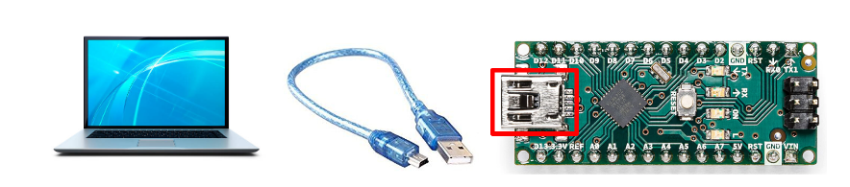
Fig 2.1 CONFIGURE ARDUINO uNO WITH PC
Step 2: Selecting the Right Board and Port
Once a connection is established between our PC and Arduino Nano, the IDE software will configure the COM port for Arduino Nano.
INCLUDEPICTURE "https://linuxhint.com/wp-content/uploads/2022/08/How-to-Program-Arduino-Nano-6.png" \* MERGEFORMATINET INCLUDEPICTURE "https://linuxhint.com/wp-content/uploads/2022/08/How-to-Program-Arduino-Nano-6.png" \* MERGEFORMATINET 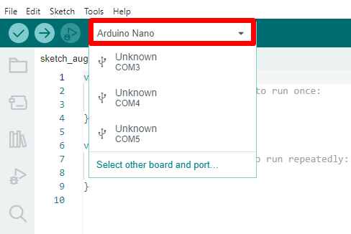
Fig 2.2 ARDUINO UNO PORT
Latest versions of IDE can configure the Arduino port itself; some older versions might be unable to do that so here is a manual way to do it.
First select Arduino board, select menu item Tools>Board>Arduino AVR Boards>Arduino UNO:
INCLUDEPICTURE "https://linuxhint.com/wp-content/uploads/2022/08/How-to-Program-Arduino-Nano-7.png" \* MERGEFORMATINET INCLUDEPICTURE "https://linuxhint.com/wp-content/uploads/2022/08/How-to-Program-Arduino-Nano-7.png" \* MERGEFORMATINET 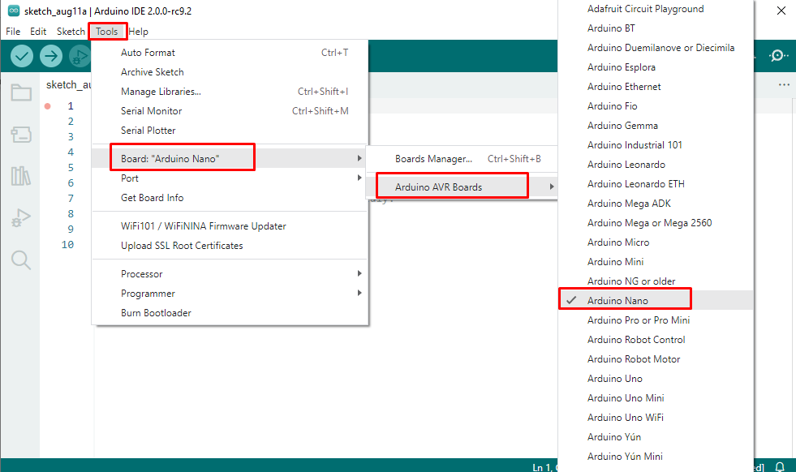
Fig 2.3 TOOLS SELECTION
Now select the COM port at which Arduino is connected. Select menu item Tools>Port>COM:
INCLUDEPICTURE "https://linuxhint.com/wp-content/uploads/2022/08/How-to-Program-Arduino-Nano-8.png" \* MERGEFORMATINET INCLUDEPICTURE "https://linuxhint.com/wp-content/uploads/2022/08/How-to-Program-Arduino-Nano-8.png" \* MERGEFORMATINET 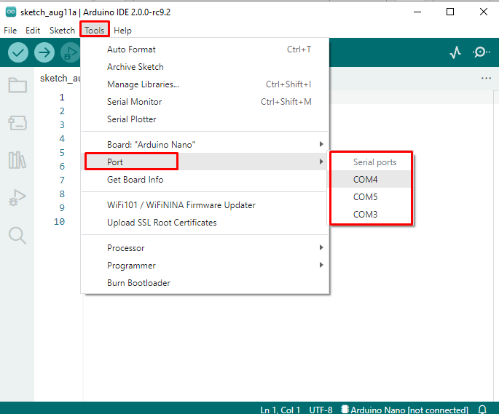
Fig 2.4 PORT SELECTION

Step 3: Opening an Example Program
Go to menu item File>Examples>Basics>Blink:

INCLUDEPICTURE "https://linuxhint.com/wp-content/uploads/2022/08/How-to-Program-Arduino-Nano-9.png" \* MERGEFORMATINET INCLUDEPICTURE "https://linuxhint.com/wp-content/uploads/2022/08/How-to-Program-Arduino-Nano-9.png" \* MERGEFORMATINET 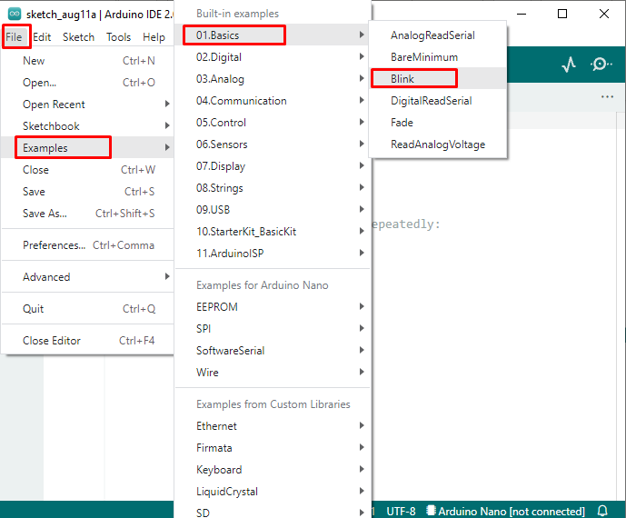
Fig 2.5 SAVED CODE INTERFACE

Step 4: Compile the Program
Now we have to compile this program using the tick button on the top left corner of the IDE. Message will appear in output window that says “Done Compiling”:
INCLUDEPICTURE "https://linuxhint.com/wp-content/uploads/2022/08/How-to-Program-Arduino-Nano-10.png" \* MERGEFORMATINET INCLUDEPICTURE "https://linuxhint.com/wp-content/uploads/2022/08/How-to-Program-Arduino-Nano-10.png" \* MERGEFORMATINET 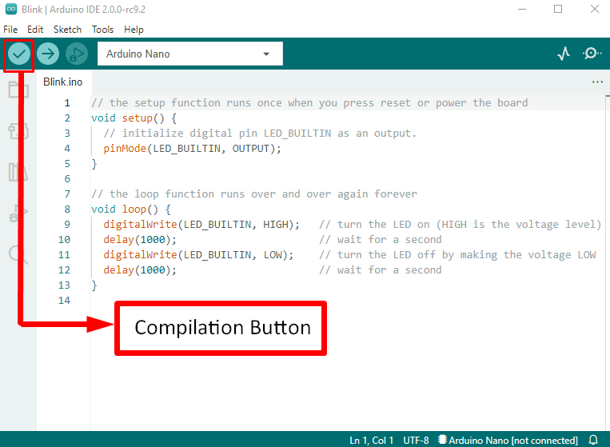
Fig 2.6 COMPILATION BUTTON

Step 5: Upload the Program
After compiling the program, now we have to upload it to Arduino Nano using the Arrow button on top, second from left. After clicking the upload message will appear “Done uploading”.
INCLUDEPICTURE "https://linuxhint.com/wp-content/uploads/2022/08/How-to-Program-Arduino-Nano-11.png" \* MERGEFORMATINET INCLUDEPICTURE "https://linuxhint.com/wp-content/uploads/2022/08/How-to-Program-Arduino-Nano-11.png" \* MERGEFORMATINET 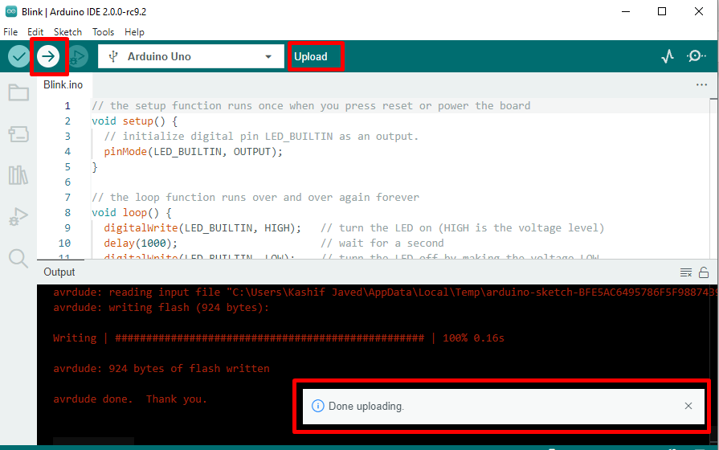
Fig 2.7 CODE UPLOADING

Step 6: Running Program
After successful upload an I/O LED will start blinking on Arduino Nano in a pattern of 1 second on and 1 second off repeatedly until we remove the or upload a new sketch in Arduino.

3.3 CODE:

#include <LiquidCrystal.h>
LiquidCrystal lcd(10,11,4,5,6,7);
const char* ssid = "iotserver";
const char* password = "iotserver123";
char res[130];
#include<dht.h>
#define dht_dpin A5

dht DHT;
int temperature, humidity,Temp,fire1,uvIntensity;

int UV_OUT = A0; //Sensor Output
int REF_3V3 = A1; //3.3V power on the Arduino board

const int RAIN=2;
const int buzzer=13;
const int light=8;
const int fan=9;
int val;
int TEMP;
int gas;
int TEMP1;
float time=0;
int distance=0;

void serialFlush(){
while(Serial.available() > 0) {
char t = Serial.read();
}
}

int hbeat=0,tempe=0,hum=0,ecg=0,raj=0;

char check(char* ex,int timeout)
{
int i=0;
int j = 0,k=0;
while (1)
{
sl:
if(Serial.available() > 0)
{
res[i] = Serial.read();
if(res[i] == 0x0a || res[i]=='>' || i == 100)
{
i++;
res[i] = 0;break;
}
i++;
}
j++;
if(j == 30000)
{
k++;
//Serial.println("kk");
j = 0;
}
if(k > timeout)
{
// Serial.println("timeout");
return 1;
}
}//while 1
if(!strncmp(ex,res,strlen(ex)))
{
//Serial.println("ok..");
return 0;
}
else
{
i=0;
goto sl;
}
}

char buff[200];
void upload1();
void setup() {
int i=0;
char ret;

pinMode(RAIN,INPUT);
pinMode(light,INPUT);
pinMode(buzzer,OUTPUT);
digitalWrite(buzzer,LOW);
Serial.begin(9600);
lcd.begin(16,2);
lcd.clear();lcd.setCursor(0, 0);lcd.print("WELCOME");
delay(3000);
serialFlush();

st:
Serial.println("ATE0");
ret = check((char*)"OK",50);
Serial.println("AT");
ret = check((char*)"OK",50);
if(ret != 0)
{
delay(100);

delay(100);
goto st;
}

delay(1000);
Serial.println("AT+CWMODE = 1");
ret = check((char*)"OK",50);
lcd.clear();lcd.setCursor(0, 0);lcd.print("CONNECTING");
cagain:
delay(1000);
serialFlush();
Serial.print("AT+CWJAP=\"");
Serial.print(ssid);
Serial.print("\",\"");
Serial.print(password);
Serial.println("\"");
if(check((char*)"OK",300))
{
lcd.clear();lcd.setCursor(0, 0);lcd.print("CONNECTING");
goto cagain;
}

delay(1000);
lcd.clear();lcd.setCursor(0, 0);lcd.print("CONNECTED");
Serial.println("AT+CIPMUX=1");
delay(1000);delay(1000);
lcd.clear();
}
unsigned long int duration = 0;
int upload=0,count=0;
void loop() {

{
DHT.read11(dht_dpin);
lcd.clear();
lcd.setCursor(0,0);
lcd.print("H=");
lcd.print(humidity=DHT.humidity);
lcd.print("%");
lcd.setCursor(8,0);
lcd.print("T=");
lcd.print(temperature=DHT.temperature);
lcd.print("C");
delay(100);
///////////////////////////////////////////////////////////////////////////////////////////////////////////
int uv_Level = analogRead_average(UV_OUT);
int ref_Level = analogRead_average(REF_3V3);

//Use the 3.3V power pin as a reference to get a very accurate output value from sensor
float output_Voltage = 3.3 / ref_Level * uv_Level;

float uvIntensity = mapfloat(output_Voltage, 0.99, 2.8, 0.0, 15.0); //Convert the voltage to a UV intensity level -numbers from datasheet-

lcd.setCursor(0,1);
lcd.print("UV(uW/cm^2)=");
lcd.print(uvIntensity);
lcd.print(" ");
TEMP1=uvIntensity;
delay(500);
upload = 1;
//////////////////////////////////////////////////////////////////////////////////////////
if(temperature >34)
{
digitalWrite(buzzer,HIGH);
delay(3000);
digitalWrite(buzzer,LOW);

upload = 1;
}
if(digitalRead(RAIN) == 0)
{
lcd.setCursor(0, 1);lcd.print("RAIN DETECTED");
digitalWrite(buzzer,HIGH);
delay(3000);
digitalWrite(buzzer,LOW);
ecg = 100;
upload = 1;
}
else
{
ecg = 0;
}

delay(500);
upload = 1;
}

count++;
if(upload == 1||count == 2)
{
count =0;
upload = 0;
upload1();
}

}
int analogRead_average(int pinToRead)
{
int NumberOfSamples = 8;
int runningValue = 0;

for(int x = 0; x < NumberOfSamples; x++)
runningValue += analogRead(pinToRead);
runningValue /= NumberOfSamples;

return(runningValue);
}

float mapfloat(float x, float in_min, float in_max, float out_min, float out_max)
{
return (x - in_min) * (out_max - out_min) / (in_max - in_min) + out_min;
}

void upload1()
{
delay(100);
Serial.println("AT+CIPSTART=4,\"TCP\",\"184.106.153.149\",80");
{
delay(1000);
serialFlush();
Serial.println("AT+CIPSEND=4,100");
{
delay(500);

serialFlush();

Serial.print("GET /update?api_key=NXDPOYOI4MLJ43YZ&");
sprintf(buff,"&field1=%04u",temperature);
Serial.print(buff);
sprintf(buff,"&field2=%04u",humidity);
Serial.print(buff);
sprintf(buff,"&field3=%04u",ecg);
Serial.print(buff);
sprintf(buff,"&field5=%04u",uvIntensity);
Serial.print(buff);
sprintf(buff,"&field4=%04u",TEMP1);
Serial.print(buff);
{
delay(500);

Serial.println("AT+CIPCLOSE");
}

}//>}//Linked

3.3.1 THINGSPEAK:
To upload data to ThingSpeak, you can use the ThingSpeak REST API or the ThingSpeak MQTT API. Here are the basic steps for using the REST API:
Create an account on ThingSpeak if you haven't already done so.
Log in to your ThingSpeak account and create a new channel.
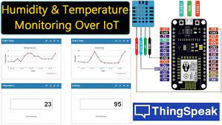
FIG 2.8 THINGSPEAK WEBSITE
Take note of the channel ID and the write API key. You will need these later.
Prepare the data that you want to upload. ThingSpeak can handle numeric data, text data, and certain image formats.
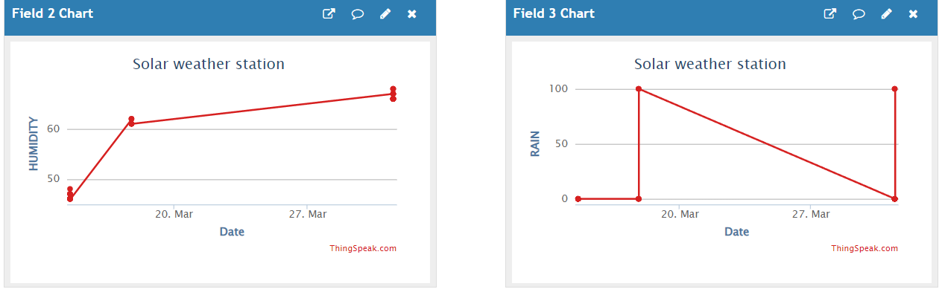
FIG2.9 HUMIDITY AND RAIN GRAPH

Construct an HTTP POST request to the ThingSpeak server using the channel ID and the write API key. The request should include the data that you want to upload.
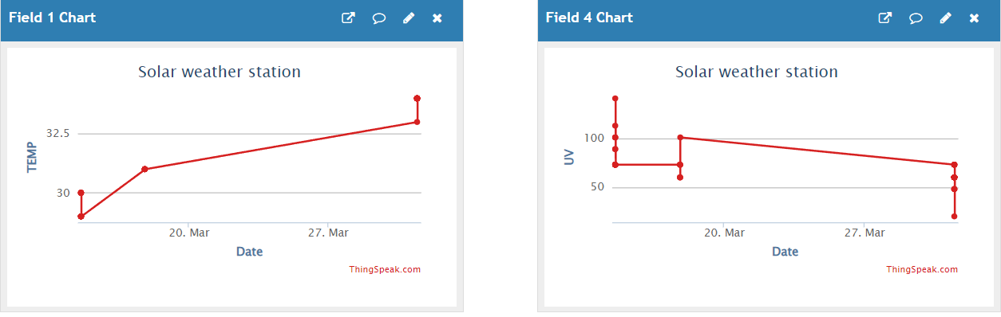
FIG 3.0 TEMPERATURE AND UV GRAPH

Send the HTTP POST request to the ThingSpeak server.
Check your channel on the ThingSpeak website to see if your data has been successfully uploaded.
Here is an example HTTP POST request in Python using the requests library:
kotlin
Copy code
import requests
channel_id = YOUR_CHANNEL_ID
write_api_key = 'YOUR_WRITE_API_KEY'
data = {'field1': '42', 'field2': 'hello world'}
response = requests.post('https://api.thingspeak.com/update.json', data=data, params={'api_key': write_api_key})
In this example, replace YOUR_CHANNEL_ID and YOUR_WRITE_API_KEY with your actual channel ID and write API key, respectively. Also, replace 'field1': '42' and 'field2': 'hello world' with the actual data that you want to upload to your channel.

3.4 CONSTRUCTION:
Constructing a solar weather station using ESP8266, Gy1145, DHT11, raindrop sensor on an Arduino Uno involves several steps. Here are the general steps to follow
Gather the components: You will need an ESP8266 module, Gy1145 sensor, DHT11 sensor, raindrop sensor, breadboard, jumper wires, and a 9V solar panel with a charge controller and battery.
Connect the components to the Arduino Uno: Connect the sensors and modules to the Arduino Uno using jumper wires and a breadboard. Connect the power supply (9V solar panel with a charge controller and battery) to the Arduino Uno.
Set up the software environment: Download and install the Arduino IDE on your computer. Install the required libraries for the sensors (Gy1145, DHT11, and raindrop sensor). Upload the appropriate code to the Arduino Uno using the Arduino IDE.
Configure the ESP8266: Connect the ESP8266 to the Arduino Uno using jumper wires. Configure the ESP8266 module to connect to a Wi-Fi network and send data to a web server. Use the appropriate code to set up the ESP8266.
Calibrate the sensors: Test and calibrate the sensors to ensure that they are providing accurate readings.
Mount the sensors and power supply: Mount the sensors and the power supply in a weatherproof enclosure. Place the enclosure in a suitable location to gather weather data.
Upload data to a web server: Use the ESP8266 to upload the weather data to a web server. This will allow you to access the data remotely and view the weather conditions in real-time.
Overall, constructing a solar weather station using ESP8266, Gy1145, DHT11, raindrop sensor on an Arduino Uno requires a basic understanding of electronics and programming. With the right components and software, you can easily build a functional weather station that can provide accurate and reliable weather data.

3.5 CIRCUIT DIAGRAM:
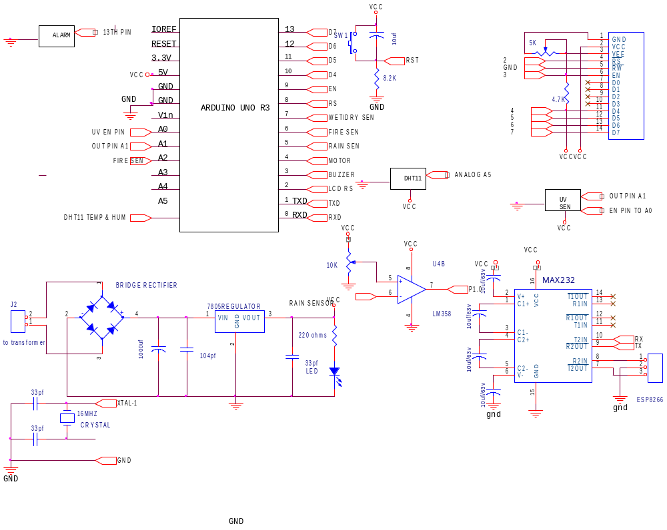
FIG 3.1 CIRCUIT DIAGRAM

3.6 BLOCK DIAGRAM:

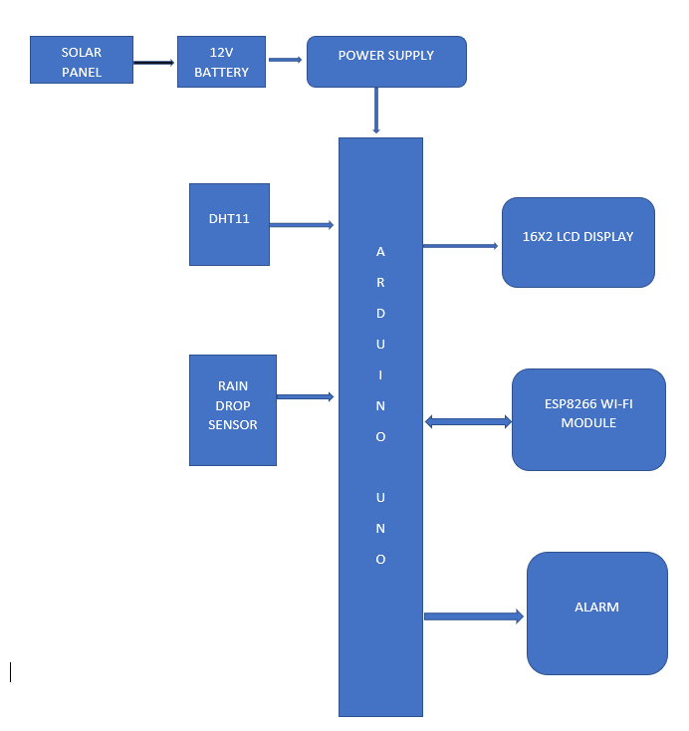
FIG 3.2 BLOCK DIAGRAM

3.7 WORKING:
Working procedure for a solar weather station that runs with an ESP8266, DHT11, GY1145, rain drop sensor, and Arduino Uno:
Collect weather data: The sensors (DHT11, GY1145, rain drop sensor) will collect data on temperature, humidity, air pressure, UV index, and rainfall.
Connect sensors to ESP8266: Connect the sensors to the ESP8266 via their respective pins. Make sure to also connect the power and ground wires correctly.
Program ESP8266: Use the Arduino IDE to program the ESP8266 to collect data from the sensors and transmit it to a remote server or a local display. You can use the ESP8266 library to set up the WIFI connection and to send HTTP requests.
Power the system: Use a solar panel to power the weather station. The solar panel will convert sunlight into electricity, which will charge a battery. The battery will power the Arduino Uno and the ESP8266.
Display weather data: You can choose to display the weather data locally using an LCD display, or you can transmit the data to a remote server using an API. You can also use a mobile app to display the data.
Data analysis and storage: You can store the data in a database for future analysis. You can also use machine learning algorithms to analyze the data and make predictions about the weather.
Overall, the procedure involves collecting data from sensors, transmitting the data to a server or display, and analysing the data for insights into weather patterns. The solar panel provides a renewable source of power for the system, making it an eco-friendly and sustainable solution.
collected weather data from the solar weather station is sent to a cloud-based IoT platform called ThingSpeak.
ThingSpeak is an open-source Internet of Things (IoT) platform that allows users to collect, analyze, and visualize sensor data in real-time. It is an easy-to-use platform that enables the creation of custom IoT applications and integrates with various hardware devices and protocols.
To upload the weather data to ThingSpeak, the ESP8266 in the weather station can be programmed with the ThingSpeak library, which provides functions for sending data to ThingSpeak channels. The ESP8266 can send the data using HTTP POST requests to the ThingSpeak API, which then processes the data and stores it in a database.

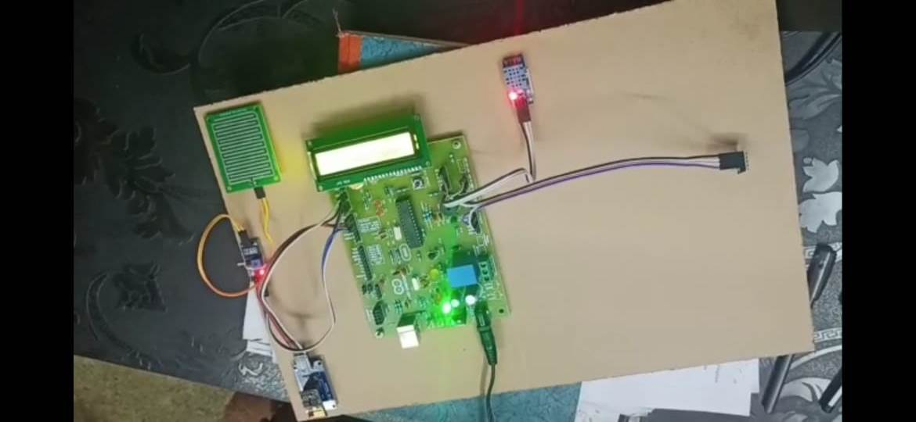
FIG 3.3 COMPLETE DEVICE INTERFACE
Once the data is uploaded, it can be viewed in real-time using ThingSpeak's built-in visualization tools, such as graphs and gauges. The data can also be exported to other platforms for further analysis, such as MATLAB for advanced data processing and analysis.
Overall, uploading the weather data to ThingSpeak enables users to monitor and analyze the data remotely, and provides a convenient platform for creating custom IoT applications based on the weather station data

CHAPTER 4

4.1 RESULT:
A solar weather station is a system that can measure and record weather conditions such as temperature, humidity, air pressure, UV index, and rainfall. By collecting and analyzing this data, a solar weather station can provide valuable insights into local weather patterns and trends. The overall results that a solar weather station can provide:
Real-time weather data: A solar weather station can provide real-time weather data that can be used for a variety of purposes, such as planning outdoor activities, monitoring agricultural conditions, and forecasting weather events.
Historical weather data: By collecting weather data over a period of time, a solar weather station can provide historical data that can be used to track weather patterns and trends. This data can be useful for understanding how weather conditions are changing over time and how they may impact different aspects of the environment.
Environmental monitoring: Solar weather stations can be used to monitor environmental conditions such as air quality, soil moisture, and water quality. This data can be used to identify areas that may be impacted by pollution or other environmental factors.
Renewable energy monitoring: A solar weather station can be used to monitor solar radiation and other factors that affect the efficiency of solar panels. This data can be used to optimize the performance of solar energy systems and improve their overall efficiency.
Disaster preparedness: By monitoring weather conditions, a solar weather station can provide early warnings for potential weather events such as storms, floods, and hurricanes. This data can help communities prepare for and respond to natural disasters.
Overall, a solar weather station can provide valuable data for a variety of applications and can help us better understand and manage our environment. With advances in IoT technology and cloud-based platforms, solar weather stations are becoming more accessible and easier to use, making them an important tool for both professionals and enthusiasts alike.

CHAPTER 5

5.1 Conclusion:
In conclusion, a solar weather station is a valuable tool for monitoring and analyzing weather conditions, especially in remote or off-grid locations where access to power may be limited. The station harnesses the power of the sun to provide energy for the instruments, allowing for continuous and accurate measurements of various weather parameters.
The data collected can be used for a variety of purposes, including weather forecasting, agricultural management, and disaster preparedness. Overall, a solar weather station is a cost-effective and sustainable solution for weather monitoring in a wide range of settings.
Solar weather stations are not only beneficial in remote locations, but also in urban areas where there may be power outages or disruptions due to severe weather events.
Additionally, solar weather stations can contribute to our understanding of climate change by providing long-term data on weather patterns and trends. They can also help identify areas that are most vulnerable to extreme weather events, allowing for targeted interventions to improve community resilience.
With the increasing emphasis on renewable energy and sustainable development, solar weather stations are likely to become more widely used and integrated into weather monitoring systems around the world.

5.2 FUTURE SCOPE:
The future scope for solar weather stations is promising as there is an increasing demand for sustainable and eco-friendly solutions for weather monitoring. Here are some potential areas of growth for solar weather stations:
- Smart and connected weather stations: With the advancement of Internet of Things (IOT) technology, solar weather stations can be connected to the internet, allowing for real-time monitoring and analysis of weather data. This can be particularly useful for emergency response and disaster management.
- Artificial intelligence (AI) and machine learning: AI and machine learning can be used to analyze vast amounts of data collected by solar weather stations to identify patterns and predict weather patterns. This can help improve weather forecasting accuracy and provide early warnings for extreme weather events.
- Integration with renewable energy systems: Solar weather stations can be integrated with other renewable energy systems such as wind turbines and hydropower generators to create self-sustaining weather monitoring systems that are completely off-grid.
- Expansion into developing countries: Solar weather stations can play a crucial role in developing countries that lack the infrastructure for traditional weather monitoring systems. Solar weather stations are cost-effective, require minimal maintenance, and can be easily installed in remote areas, providing valuable weather data to support agriculture, disaster management, and other critical areas.
Application in space exploration: Solar weather stations can be used to monitor weather conditions on other planets, including Mars. NASA has already used solar-powered weather stations to gather data on Mars' weather patterns.
Integration with other environmental monitoring systems: Solar weather stations can be integrated with other environmental monitoring systems to provide a comprehensive view of the environment. For example, solar weather stations can be integrated with water quality monitoring systems to provide a complete picture of the impact of weather conditions on water quality.
Integration with precision agriculture: Solar weather stations can be used in precision agriculture to optimize crop yields by providing real-time data on weather conditions, allowing farmers to make informed decisions on irrigation, fertilization, and other factors affecting crop growth.
Overall, the future of solar weather stations looks bright as they continue to evolve and expand their applications to meet the growing demand for sustainable and eco-friendly weather monitoring solutions.

5.3 REFERENCES:
ESP8266
https://youtu.be/dGrJi-ebZgI
DHT11
https://youtu.be/OogldLc9uYc
https://en.wikipedia.org/wiki/Dihydrotestosterone
https://www.geeetech.com/wiki/index.php/DHT_11_Humidity_%26_Temperature_Sensor
GY1145
https://youtu.be/xcTVln-L5Pw
https://en.wikipedia.org/wiki/Radiation_exposure
RAIN DROP SENSOR
https://youtu.be/qtqtMLmRqZI
https://robocraze.com/blogs/post/what-is-a-raindrop-sensor
OTHER REFERENCES
https://www.instructables.com/Solar-P...

TEAM MEMBER DETAILS

NAME: CH. VENKATA MANI CHANDAN
PIN NUMBER: 20L65A0217
PHONE NUMBER: 6301977145
GMAIL: manichandanchinthapalli@gmail.com

NAME: M. HARIKA
PIN NUMBER: 20L65A0224
PHONE NUMBER: 9912954678
GMAIL: majjiharika017@gmail.com

NAME: S. SURESH KRISHNA
PIN NUMBER: 20L65A0212
PHONE NUMBER: 7981359112
GMAIL: sureshkrishna07808@gmail.com

NAME: K. MOHITH KUMAR
PIN NUMBER: 20L65A0208
PHONE NUMBER: 9381319238
GMAIL: mohithkumar412@gmail.com

